

UNDERGRADUATE PROJECT PROPOSAL

|  |  |
| --- | --- |
| **Project Title:** | **Forest Fire Detection and Severity Assessment Using Improved YOLOv5 on Satellite Imagery** |
| **Surname:** | **Li** |
| **First Name:** | **Qinglian (Jane)** |
| **Student Number:** | **202118010402** |
| **Supervisor Name:** | **IRFAN ULLAH** |
| **Module Code:** | **CHC 6096** |
| **Module Name:** | **Project** |
| **Date Submitted:** | **November 11th 2024** |

**Table of Contents**

1 Introduction 3

1.1 Background 3

1.2 Aim 4

1.3 Objectives 4

1.4 Project Overview 4

1.4.1 Scope 4

1.4.2 Audience 4

2 Background Review 5

3 Methodology 6

3.1 Approach 6

3.1.1 YOLOv5 6

3.1.2 DataSet 8

3.2 Technology 9

3.3 Version management plan 9

4 Project Management 10

4.1 Activities 10

4.2 Schedule 11

4.3 Data management plan 12

4.4 Project Deliverables 13

5 References 14

# **Introduction**

## **Background**

Forests as a crucial component for maintaining the ecological balance of the Earth [1], [2], encompass abundant natural resources [3], [4] and offer the environment requisite for human survival [5]. Nevertheless, unforeseeable human factors and natural disasters have triggered the rapid and uncontrollable spread of forest fires [1], [3], [6], posing a significant threat to ecosystems and human society, including direct losses of life and property, as well as long-term resource pollution issues [7], [8], [9]. As indicated by statistics from the Global Wildfire Information System, the average burned area of each wildfire amounts to as high as 20 hectares, and over 25,000 hectares of forest are devastated by wildfires annually [10]. Hence, detecting the location and severity of forest fires rapidly and precisely is an essential measure to alleviate their detrimental effects.

Although traditional monitoring methods, such as ground sensors [11] and drone patrols [12], [13], have reduced the incidence of forest fires to some extent, they are still limited by factors such as response speed and coverage [2], [6], [12]. With the rapid development of remote sensing technology, such as high-coverage datasets provided by Moderate Resolution Imaging Spectroradiometer (MODIS) satellites offer a unique perspective for fire monitoring, solving the dilemma of quickly covering large areas and providing valuable data resources for early detection and dynamic tracking of fires [13], [14]. However, due to the relatively low spatial resolution of imagery and the diverse manifestations of areas affected by fires, it is challenging to directly determine the exact location and severity of fires based on satellite imagery data alone. The application of machine learning techniques, in particular Convolutional Neural Networks (CNN), has yielded significant outcomes in the domains of image classification and target detection [15], which has brought new opportunities for remote sensing fire detection [16], [17].

In this project, an improved YOLOv5-based deep learning framework is proposed to be trained to analyze satellite data to automatically identify areas where forest fires are occurring, estimate burned areas and assess fire severity. This approach achieves a faster and more accurate detection of forest fires, which enables rescuers to quickly understand the size of the fire and its potential impacts and formulates a more effective emergency response strategy. The rest of the proposal is structured as follows: In section 2, review the literature and provide a comparative analysis of existing approaches. Section 3 introduces the techniques required for the project research and the processing of data sets. The project management plan is presented in section 4 and the reference paper for the proposal is demonstrated in section 5.

## **Aim**

The aim of this proposed project is to develop a deep learning framework based on YOLOv5 to quickly identify the location of active fires, estimate the burned area, and classify the severity of fires by analyzing satellite imagery.

## **Objectives**

There are nine objectives proposed of the project.

* Review the relevant literature and evaluate existing forest fire monitoring models.
* Select and collect appropriate data
* Preprocess the image data by re-sizing, cropping, and normalization.
* Split the data into training, validation, and test sets.
* Design an improved YOLOv5 model suitable for forest fire identification.
* Use the training set to train the constructed model.
* Use verification sets to evaluate the performance of the trained model on new data.
* Use test sets to test the accuracy of the model on the forest fire detection.
* Presenting the results of the research to the audience.

## **Project Overview**

### **Scope**

The purpose of this proposed project is to develop a deep learning framework based on YOLOv5 and assessment of satellite image data captured via MODIS, which aims to facilitate rapid detection, estimate burn areas and assessment of the severity of forest fires. Through the application of deep learning techniques, it is possible to enhance the accuracy and responsiveness of the forest fire monitoring system, thereby facilitating the implementation of timely emergency management measures during the initial stages of a fire, which can mitigate the impact of ecological damage and economic losses. Furthermore, this research contributes to more efficient wildfire monitoring and response strategies and provides referable cases for advancing academic research in the field of remote sensing image processing.

### **Audience**

This proposed project will prove beneficial to forest managers, emergency rescue teams and the general public. Primarily, forest managers can utilize the automated systems deployed for the monitoring and management of forest resources, particularly during periods of elevated fire risk, thereby enabling the provision of early warnings and the implementation of preventive measures. The swift and precise dissemination of information regarding the location and extent of fires can facilitate the prompt response of rescue teams, thereby reducing the loss of life and property. Through the real-time issuance of fire warning notifications, the public can access timely information on the risks associated with forest fires, enabling them to safeguard their lives and property, while also fostering awareness of forest fire prevention measures.

# **Background Review**

This proposed project investigates and compares from the state of the art techniques for forest fire detection using deep learning methods. In [3], Khan et al. put forward a transfer learning approach based on VGG19 for the detection of forest fires. The experiment utilized 80% of the data in the DeepFire dataset for training and attained an accuracy of 95.72% in the 20% test set, where there were 950 images each for the fire class and the non-fire class. Seydi et al. [1] employed a Landsat-8 image set for forest fire detection and proposed a deep learning framework Fire-Net integrated by YOLOv5 and U-Net network, which improved the accuracy of forest small fire detection under different conditions. Yuan et al. [5] employed the 85% FLAME dataset as a training set to enable the model to acquire global context information by incorporating a multi-head self-attention (MSA) module before each YOLO header. Experimental results have proven that this approach can markedly enhance the efficacy of forest fire detection across different scales while preserving the real-time performance of fire detection. In contrast to the approach taken in [5], [18] considered the diversity of forest fire scenarios and integrated YOLOv5 with EfficientNet, significantly reducing the false alarm rate in forest fire detection by learning global information. The model demonstrated a high level of accuracy in recognizing fire images, achieving 99.6% accuracy on 476 images and 99.7% accuracy on 676 images. Kang et al. [19] proposed a deep learning model based on geostationary satellite Himawari-8 AHI data, which employed temporal and spatial information features to markedly reduce the detection delay of forest fires. [20] proposed a Forest Smoke-Fire Net (FSF-Net) model based on Mask R-CNN, which combining MODIS remote sensing images with regional dynamic brightness temperature thresholds. The study demonstrates that the model can effectively circumvent the issue of erroneous identification and missed detection resulting from interference such as cloud and fog, and significantly improve the precision and dependability of forest smoke detection. Yang et al. [21] introduced a novel Squeeze-Excitation Spatial Multi-Scale Transformer Learning (SESMTML) algorithm that integrates deep learning with remote sensing imagery to tackle the spatial and temporal challenges in forest fire risk prediction models and the lack of universality due to regional inconsistencies.

|  |  |  |  |
| --- | --- | --- | --- |
| **Research** | **Model** | **DataSet** | **Performance Index** |
| [Khan](https://onlinelibrary.wiley.com/authored-by/Khan/Ali) et al. [3] | VGG19 | DeepFire | Accuracy = 98.89%  Precision = 95.72% |
| Seydi et al. [1] | Fire-Net  (YOLOv5 + U-Net) | Landsat-8 | Overall Accuracy = 97.35%  Precision = 93.49% |
| Yuan et al. [5] | YOLOv5 + Transformer | FLAME,  self-built fire dataset | Accuracy = 93.25%  Precision = 92.85% |
| Xu et al. [18] | YOLOv5 + EfficientNet | BowFire,  FD-dataset,  ForestryImages,  VisiFire | Accuracy = 99.6%  Average Precision = 85.5% |
| Kang et al. [19] | CNN + RF | Himawari-8 AHI | Overall Accuracy = 98%  Precision = 91% |
| Ding et al. [20] | FSF-Net  (Mask R-CNN) | MODIS_Smoke_FPT dataset | Accuracy = 89.12% |
| Yang et al. [21] | SESMTML  (CNN + Transformer) | FireRisk | Overall Accuracy =  83.18%  Precision = 83.05% |

Table 1 Comparison of different research

# **Methodology**

## **Approach**

**3.1.1 YOLOv5**

The YOLOv5 algorithm is characterized by multi-scale detection and lightweight target localization, and is mainly composed of three parts: Backbone, Neck, and Head [22]. The YOLOv5 structure is shown in Fig. 1. The Backbone network as the core of feature extraction in YOLOv5, comprises BottleneckCSP and Focus modules. It extracts features from the input image through multiple convolutional layers and pooling layers, and fuses feature maps of different scales via cross-layer connections and channel compression, ultimately outputting feature maps with semantic information.

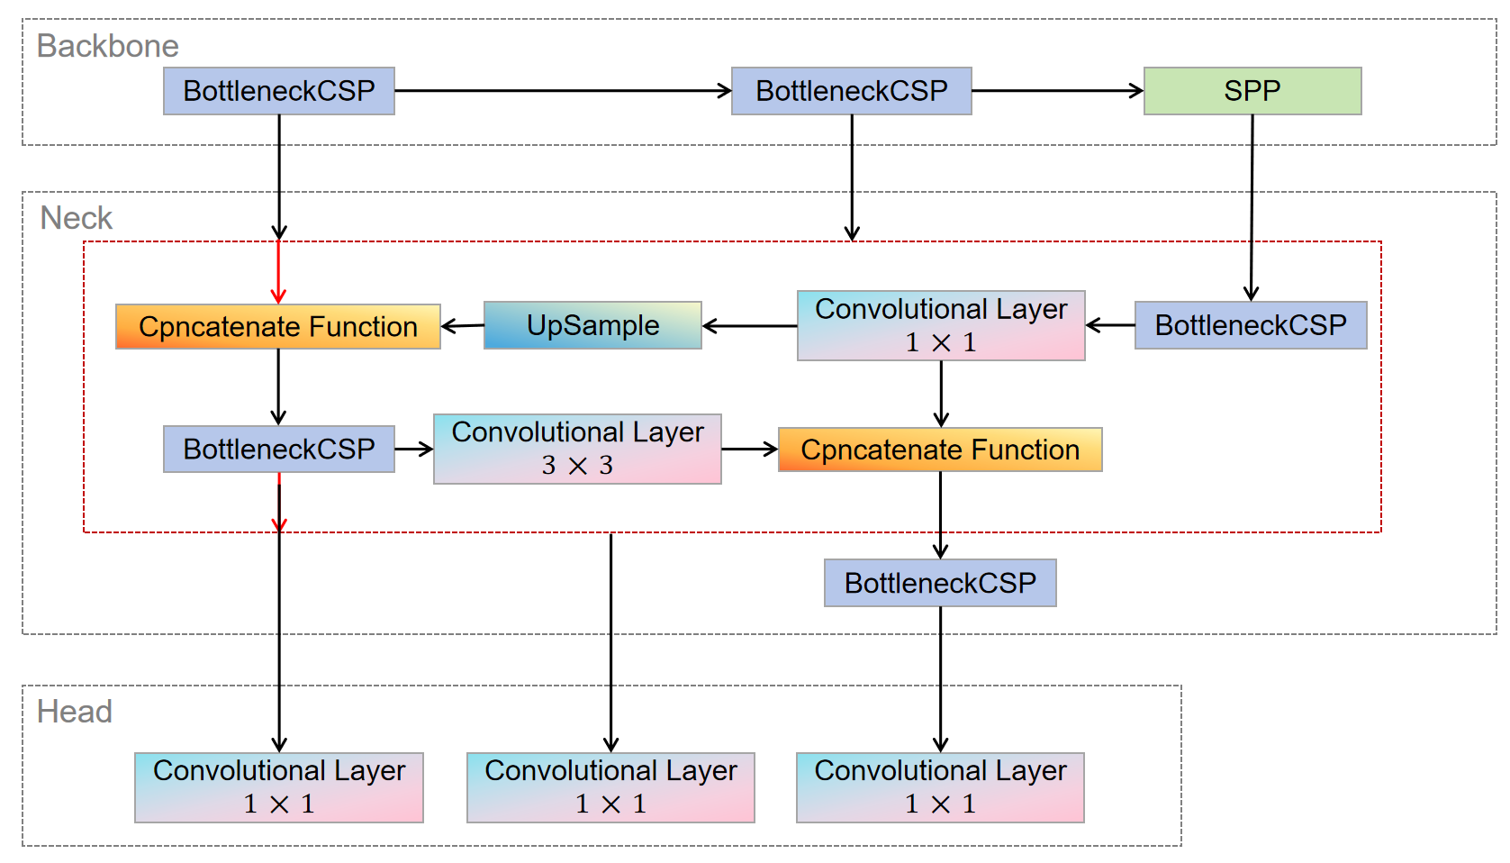

Fig. 1 YOLOv5 Structure

In the task of forest fire detection, detection speed and accuracy are of vital importance, and the compact model size determines the inference efficiency on resource-scarce edge devices. BottleneckCSP draws on the CSPnet network model and consists of three convolutional layers and multiple Res unit modules Concate, which enhances the learning performance of the entire convolutional neural network while significantly reducing the computational cost [22], [23]. The Focus module conducts slice operations on the image, expands the input channels to four times the original, and acquires a downsampled feature map through a single convolution. This achieves downsampling while reducing the computational cost and improving the training speed of the model.

In the Neck, the FPN and PAN structures are adopted, and the CSP2 structure inspired by CSPNet is introduced to enhance the feature fusion capability of the network [22]. The CSP module first divides the feature map of the base layer into two parts and then combines them through a cross-stage hierarchical structure, reducing the computational cost while guaranteeing the detection accuracy [23]. The FPN structure transmits and fuses the high-level semantic features through upsampling in a top-down manner; while the PAN structure transmits the location features of the lower layers through downsampling in a bottom-up manner [22]. The combination of the conventional FPN layer and the PAN structure fuses the extracted semantic features and location features, and simultaneously fuses the features of the main body and the detection layer, enabling the model to obtain more abundant feature information and significantly enhance its detection ability. Forest fires typically progress from small-scale fires (ground fires) to medium-scale fires (trunk fires) and then to large-scale fires (canopy fires). Multi-scale detection of YOLOv5 ensures that the model can track the size changes during the evolution of the fire. The Spatial Pyramid Pooling (SPP) module applies pooling operations at different scales () for multi-scale fusion, ensuring that the output features are invariant and multi-scale and avoiding the loss of some information [23]. In the Head network structure, as shown in Equation (1), YOLOv5 employs the CIoU Loss as the loss function for the bounding box [22], [23]. By adding an influencing factor to the DIoU Loss, the scale information of the aspect ratio of the bounding box is considered.

|  |  |
| --- | --- |
|  | (1) |

**3.1.2 DataSet**

This proposed project intends to use the Wildfire Prediction Dataset (Satellite Images) from Kaggle for the classification problem of forest fires and no-fire images. The dataset is derived from satellite images of areas that have previously experienced wildfires in Canada and is divided into two classes: fire and no-fire. The fire class contains forest and mountain regions or images with invisible black flames or gray smoke clouds. In contrast, the no-fire class contains images of forests and cities from different angles. Some images of both classes in the Wildfire dataset are shown in Fig. 2.

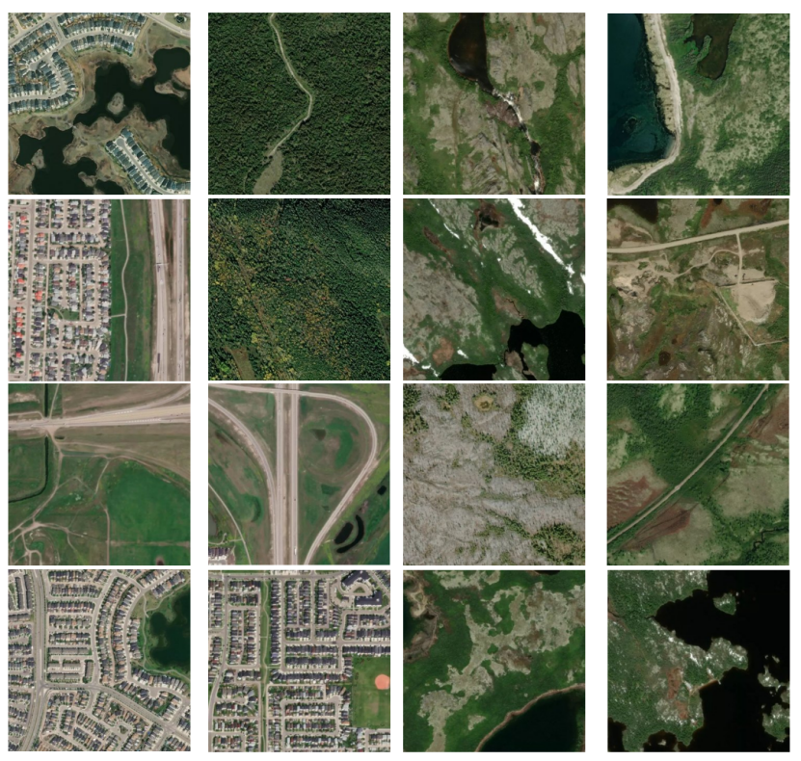

Fig. 2 Images of fire and no-fire classes

There are a total of 42,850 images in the Wildfire dataset, of which 22,710 are fire examples and the remaining 20,140 belong to the no-fire class. All images have an initial resolution of 350 × 350 pixels. This project considers dividing the dataset into three classes as shown in Table 2, with 70% of the data used for training, 15% for testing, and the remaining 15% for validation.

|  |  |  |  |  |
| --- | --- | --- | --- | --- |
| **DataSet** | **Training** | **Testing** | **Validation** | **Total** |
| Fire | 15898 | 3406 | 3406 | 22710 |
| No-fire | 14098 | 3021 | 3021 | 20140 |
| Total | 29996 | 6427 | 6427 | 42850 |

Table 2 Dataset splitting

## **Technology**

The techniques used to implement these projects are shown in the following table.

|  |  |  |
| --- | --- | --- |
| Software | Framework | TensorFlow2.0 |
| Language | Python 3.x |
| Operating System | Windows 11 |
| System development | IntelliJ IDEA 2023.2.1/ Visual Studio Code |
| SpringBoot |
| Navicat Premium 16 |
| CSS3, HTML 5, JavaScript |
| Version management plan | Baidu Cloud |
| GitHub repository |
| Hardware | GPU | NVIDIA GeForce MX450/ NVIDIA Tesla T4*2/ NVIDIA Tesla P100 |
| CPU | The 11th Gen Intel® Core™ i5-11320H / i7-11390H Processors / CPU 4 cores |
| Memory | 16GB |

Table 3 Tools and techniques for development

## **Version management plan**

As shown in the table below, four versions of the project are expected.

|  |  |
| --- | --- |
| Version | Description |
| 1.0 | Implement YOLOv5 models |
| 2.0 | Implement the improved YOLOv5 model |
| 3.0 | Implement the integration of YOLOv5 with other CNN models |
| 4.0 | Optimized the integrated YOLOv5 model |

Table 4 Version management

To avoid confusion or accidental loss of project documentation and code, the following resources are used to effectively manage all documentation:

* Baidu Cloud, where I sync and store project changes in order to revert back to the correct version in a timely fashion.

URL: <https://pan.baidu.com/s/1Q67PsmEjM_C2G1W-kq2p_Q?pwd=o52s>.

* GitHub repository, where I will upload the code and related work for the confirmed version model as a backup.

URL: <https://github.com/YQJane/L6C4-202118010402-Project>.

# **Project Management**

## **Activities**

|  |  |
| --- | --- |
| Objective | Activities |
| 1. Review the relevant literature and evaluate existing forest fire monitoring models. | * Research and read related papers and codes online to get ideas. * Research and collect deep leaning algorithm for forest fire detection. * Search for similar automatic fire monitoring software and make a comparison table. * Complete the literature review. |
| 1. Select and collect appropriate data | * Search and download suitable datasets. |
| 1. Preprocess the image data by re-sizing, cropping, and normalization. | * Convert image data to model acceptable formats, and the normalized processing, so that the input to the neural network. |
| 1. Split the data into training, validation, and test sets. | * Tools such as LabelImg were used to label the fire area in the image and generate the training data set. * The training set is used to learn the model parameters. * Validation sets are used to adjust the hyperparameters and monitor performance of the models. * The test set is used to evaluate the accuracy of the model. |
| 1. Design an improved YOLOv5 model suitable for forest fire identification. | * From the existing CNN models, YOLOv5 model is selected for improvement. * Considering the integration of YOLOv5 with other CNN models to improve the performance of forest fire recognition. * Optimized design of YOLOv5 algorithm. |
| 1. Use the training set to train the constructed model. | * In the training process, the backpropagation algorithm is used to update the weights and biases in the network, so as to gradually learn the fire characteristics in the image. |
| 1. Use verification sets to evaluate the performance of the trained model on new data. | * Evaluate the performance of the model using metrics such as accuracy, precision, recall rate, and adjust and improve it as needed. |
| 1. Use test sets to test the accuracy of the model on the forest fire detection. | * Use the trained model test the accuracy of the location identification of active fires. * Use the trained model test the precision of the estimate the burned area * Use the trained model predicts new image, judging the severity of the fire. |
| 1. Presenting the results of the research to the audience. | * Show the innovation of CNN model. * Summarize its working process. * Create PPT to present research findings. |

Table 5 Activities table

## **Schedule**

Below is the schedule for this project, which starts on October 21st 2024 and ends on April 1st 2025. The details are as follows:

* Literature review - 3 week
* Complete project proposal - 2 weeks
* Comparison of existing models - 3 weeks
* Database selection and download - 2 week
* Data preprocessing - 2 week
* Data set partition - 2 week
* Build the model - 4 weeks
* Training model - 3 weeks
* Evaluation model - 3 weeks
* Test model - 3 weeks
* Complete the final report - 3 weeks
* Create PPT - 1 week
* Total effort - 31 weeks

The schedule is represented by Gantt as below.

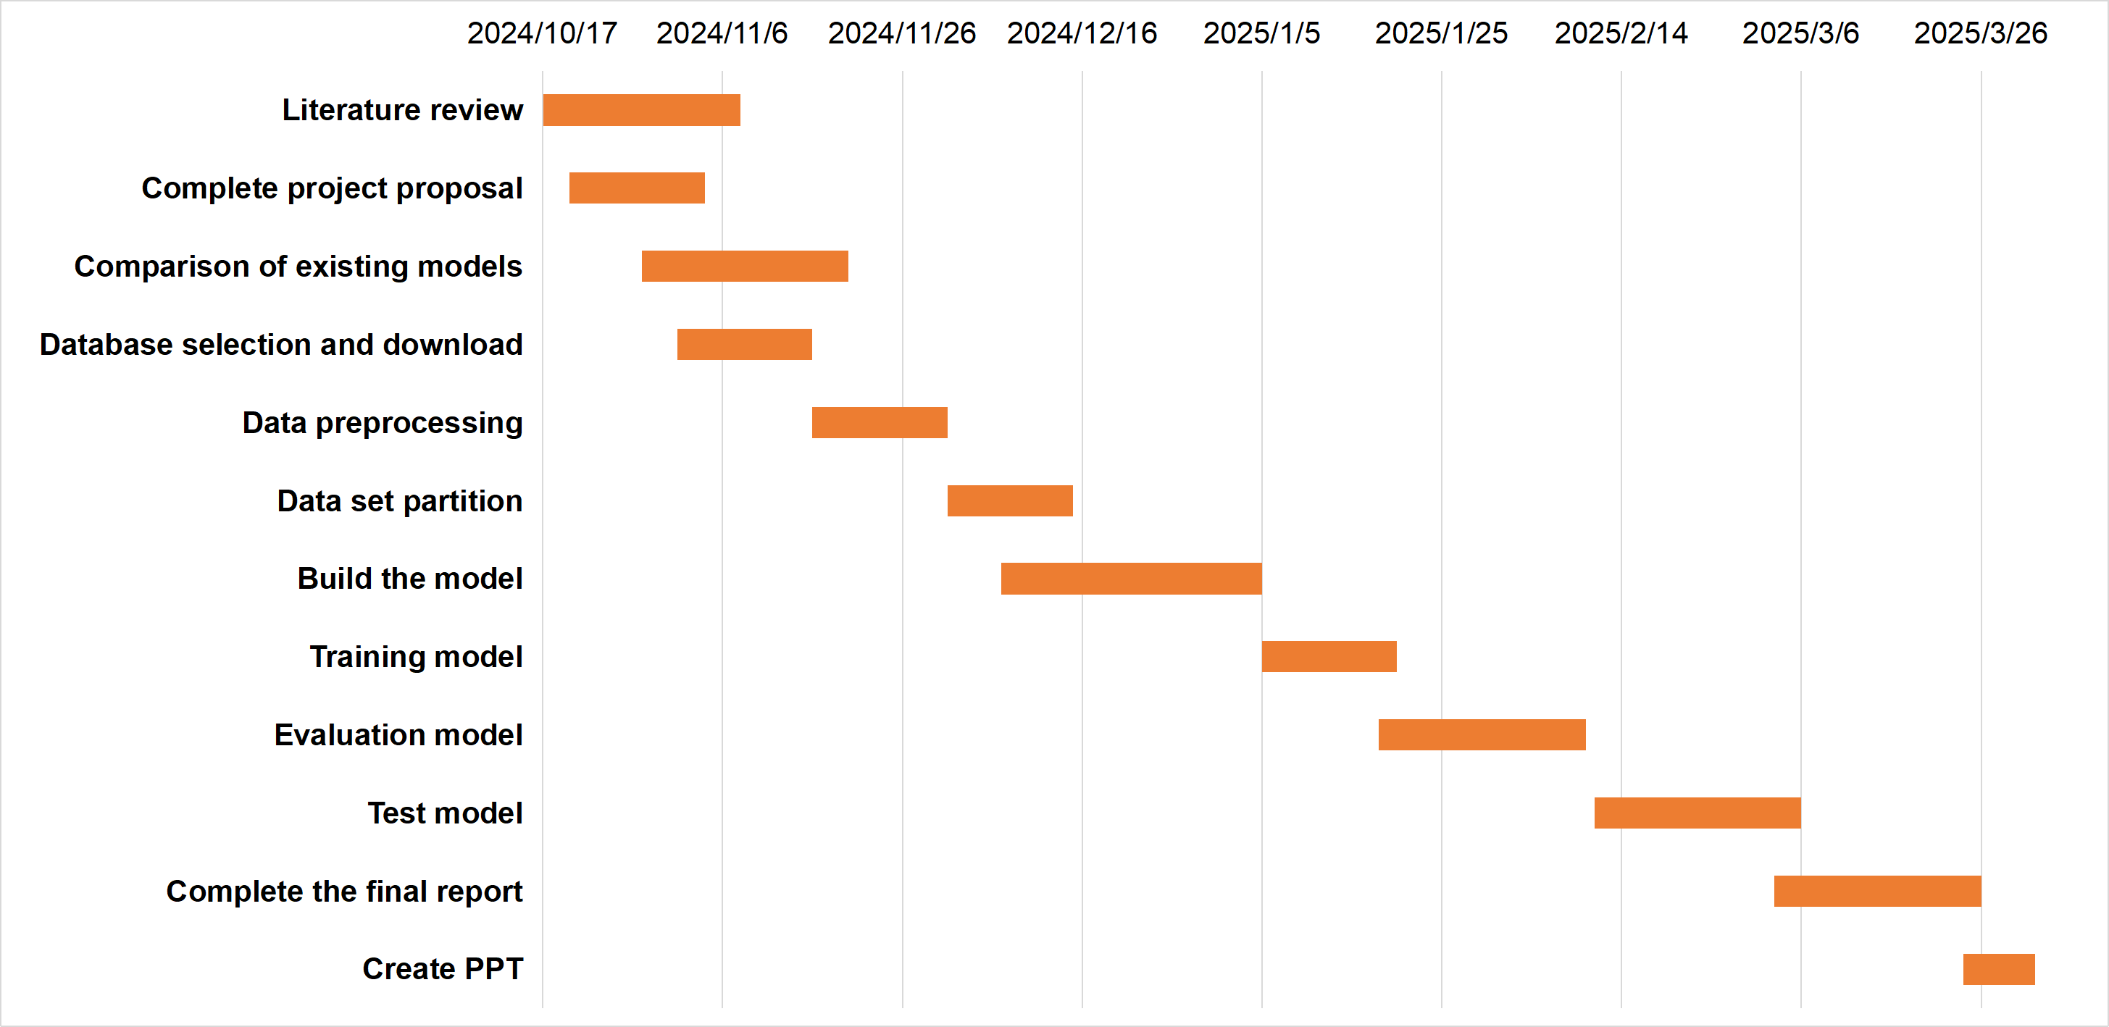

Fig. 3 Gantt chart for schedule

## **Data management plan**

1. Datasets was downloaded from NASA FIRMS (the Fire Information for the Resource Management System), links are as follows: <https://firms.modaps.eosdis.nasa.gov/>.
2. Relevant literature resources will be downloaded from academic websites such as Google Scholar and Semantic Scholar.
3. Using MyBib to manage references.
4. All documents and work will be stored on the flash drive and will be automatically backed up to the Baidu Cloud drive.
5. Baidu Cloud Link is: <https://pan.baidu.com/s/1Q67PsmEjM_C2G1W-kq2p_Q?pwd=o52s>. The structure of the file is shown below.



Fig. 4 Document structure

## **Project Deliverables**

There are a total of 9 deliverables.

* Ethics form
* Project proposal
* Weekly progress project reports
* Final project report
* Project code
* Project PPT
* Personal presentation
* Project dataset and website link
* Test results

# **References**

1. S. T. Seydi, V. Saeidi, B. Kalantar, N. Ueda, and A. A. Halin, “Fire-Net: A Deep Learning Framework for Active Forest Fire Detection,” *Journal of Sensors*, vol. 2022, pp. 1–14, Feb. 2022, doi: <https://doi.org/10.1155/2022/8044390>.
2. B. Özel, M. S. Alam, and M. U. Khan, “Review of Modern Forest Fire Detection Techniques: Innovations in Image Processing and Deep Learning,” *Information*, vol. 15, no. 9, Sep. 2024, doi: <https://doi.org/10.3390/info15090538>.
3. A. Khan, B. Hassan, S. Khan, R. Ahmed, and A. Abuassba, “DeepFire: A Novel Dataset and Deep Transfer Learning Benchmark for Forest Fire Detection,” *Mobile Information Systems*, vol. 2022, pp. 1–14, Apr. 2022, doi: <https://doi.org/10.1155/2022/5358359>.
4. S.-Y. Kim and A. Muminov, “Forest Fire Smoke Detection Based on Deep Learning Approaches and Unmanned Aerial Vehicle Images,” *Sensors*, vol. 23, no. 12, p. 5702, Jan. 2023, doi: <https://doi.org/10.3390/s23125702>.
5. H. Yuan, Z. Lu, R. Zhang, J. Li, S. Wang, and J. Fan, “An effective graph embedded YOLOv5 model for forest fire detection,” *Computational Intelligence*, vol. 40, no. 2, Mar. 2024, doi: <https://doi.org/10.1111/coin.12640>.
6. A. Bouguettaya, H. Zarzour, A. M. Taberkit, and A. Kechida, “A review on early wildfire detection from unmanned aerial vehicles using deep learning-based computer vision algorithms,” *Signal Processing*, vol. 190, p. 108309, Jan. 2022, doi: <https://doi.org/10.1016/j.sigpro.2021.108309>.
7. H. Yar, T. Hussain, Z. A. Khan, D. Koundal, M. Y. Lee, and S. W. Baik, “Vision Sensor-Based Real-Time Fire Detection in Resource-Constrained IoT Environments,” *Computational Intelligence and Neuroscience*, vol. 2021, pp. 1–15, Dec. 2021, doi: <https://doi.org/10.1155/2021/5195508>.
8. Saydirasulov Norkobil Saydirasulovich, Akmalbek Abdusalomov, Muhammad Kafeel Jamil, Rashid Nasimov, Dinara Kozhamzharova, and Young Im Cho, “A YOLOv6-Based Improved Fire Detection Approach for Smart City Environments,” *Sensors*, vol. 23, no. 6, pp. 3161–3161, Mar. 2023, doi: <https://doi.org/10.3390/s23063161>.
9. M. Prakash, S. Neelakandan, M. Tamilselvi, S. Velmurugan, S. Baghavathi Priya, and Eric Ofori Martinson, “Deep Learning-Based Wildfire Image Detection and Classification Systems for Controlling Biomass,” *International journal of intelligent systems*, vol. 2023, pp. 1–18, Sep. 2023, doi: <https://doi.org/10.1155/2023/7939516>.
10. E. A. Kadir, H. Irie, and S. L. Rosa, “Modeling of Wireless Sensor Networks for Detection Land and Forest Fire Hotspot,” in *2019 International Conference on Electronics, Information, and Communication (ICEIC)*, Auckland, New Zealand, Jan. 2019, pp. 1–5. doi: <https://doi.org/10.23919/ELINFOCOM.2019.8706364>.
11. V. Samborska and H. Ritchie, “Wildfires,” *Our World in Data*, Apr. 2024, Accessed: Oct. 25, 2024. [Online]. Available: <https://ourworldindata.org/wildfires>
12. B. Laszlo, R. Agoston, and Q. Xu, “Conceptual Approach of Measuring the Professional and Economic Effectiveness of Drone Applications Supporting Forest fire Management,” *Procedia Engineering*, vol. 211, pp. 8–17, Aug. 2018, doi: [https://doi.org/10.1016/j.proeng.2017.12.132.](https://doi.org/10.1016/j.proeng.2017.12.132)
13. T. J. Hawbaker, V. C. Radeloff, A. D. Syphard, Z. Zhu, and S. I. Stewart, “Detection rates of the MODIS active fire product in the United States,” *Remote Sensing of Environment*, vol. 112, no. 5, pp. 2656–2664, May 2008, doi: <https://doi.org/10.1016/j.rse.2007.12.008>.
14. C. O. Justice *et al.*, “The MODIS fire products,” *Remote Sensing of Environment*, vol. 83, no. 1–2, pp. 244–262, Nov. 2002, doi: <https://doi.org/10.1016/s0034-4257(02)00076-7>.
15. L. Alzubaidi *et al.*, “Review of deep learning: concepts, CNN architectures, challenges, applications, future directions,” *Journal of Big Data*, vol. 8, no. 53, Mar. 2021, doi: <https://doi.org/10.1186/s40537-021-00444-8>.
16. S. Geetha, C. S. Abhishek, and C. S. Akshayanat, “Machine Vision Based Fire Detection Techniques: A Survey,” *Fire Technology*, vol. 57, no. 2, pp. 591–623, Nov. 2020, doi: <https://doi.org/10.1007/s10694-020-01064-z>.
17. R. Alkhatib, W. Sahwan, A. Alkhatieb, and B. Schütt, “A Brief Review of Machine Learning Algorithms in Forest Fires Science,” *Applied sciences*, vol. 13, no. 14, pp. 8275–8275, Jul. 2023, doi: <https://doi.org/10.3390/app13148275>.
18. R. Xu, H. Lin, K. Lu, L. Cao, and Y. Liu, “A Forest Fire Detection System Based on Ensemble Learning,” *Forests*, vol. 12, no. 2, Feb. 2021, doi: <https://doi.org/10.3390/f12020217>.
19. Y. Kang, E. Jang, J. Im, and C. Kwon, “A deep learning model using geostationary satellite data for forest fire detection with reduced detection latency,” *GIScience & Remote Sensing*, vol. 59, no. 1, pp. 2019–2035, Nov. 2022, doi: <https://doi.org/10.1080/15481603.2022.2143872>.
20. Y. Ding, M. Wang, Y. Fu, and Q. Wang, “Forest Smoke-Fire Net (FSF Net): A Wildfire Smoke Detection Model That Combines MODIS Remote Sensing Images with Regional Dynamic Brightness Temperature Thresholds,” *Forests*, vol. 15, no. 5, pp. 839–839, May 2024, doi: <https://doi.org/10.3390/f15050839>.
21. J. Yang, H. Jiang, S. Wang, and X. Ma, “A Multi-Scale Deep Learning Algorithm for Enhanced Forest Fire Danger Prediction Using Remote Sensing Images,” *Forests*, vol. 15, no. 9, pp. 1581–1581, Sep. 2024, doi: <https://doi.org/10.3390/f15091581>.
22. R. Khanam and M. Hussain, “What is YOLOv5: A deep look into the internal features of the popular object detector,” *arXiv (Cornell University)*, Jul. 2024, doi: <https://doi.org/10.48550/arxiv.2407.20892>.
23. S. K. Jaiswal and R. Agrawal, “A Comprehensive Review of YOLOv5: Advances in Real-Time Object Detection,” *International Journal of Innovative Research in Computer Science and Technology*, vol. 12, no. 3, pp. 75–80, May 2024, doi: <https://doi.org/10.55524/ijircst.2024.12.3.12>.